More about isolated areas
- Roughly isolated area is analogues to vm, but major difference is VMs have a full blow os whereas isolated areas (containers) don’t have a full blow os.
- Since they don’t have full blown os,
  - CPU and other resources are allocated to application rather than os
  - This reduces the overhead of OS Patching
  - Savings on cost as containers on license costs 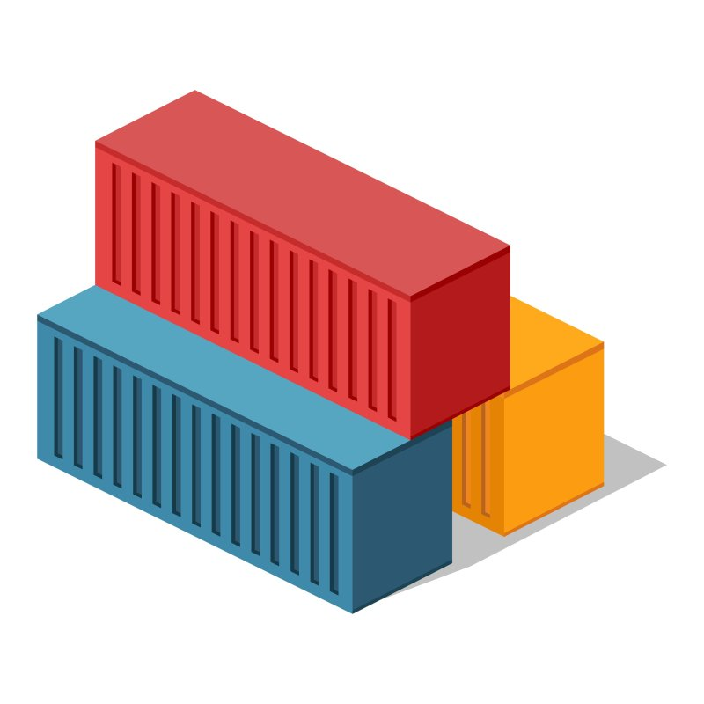
- Every container (isolate area) gets
  - CPU
  - RAM
  - Storage
  - Network (ip address)
- We will be using docker to create these isolated areas called as containers.
- Docker is British expression for Dock Worker who is responsible for loading and unloading container in the shipyard 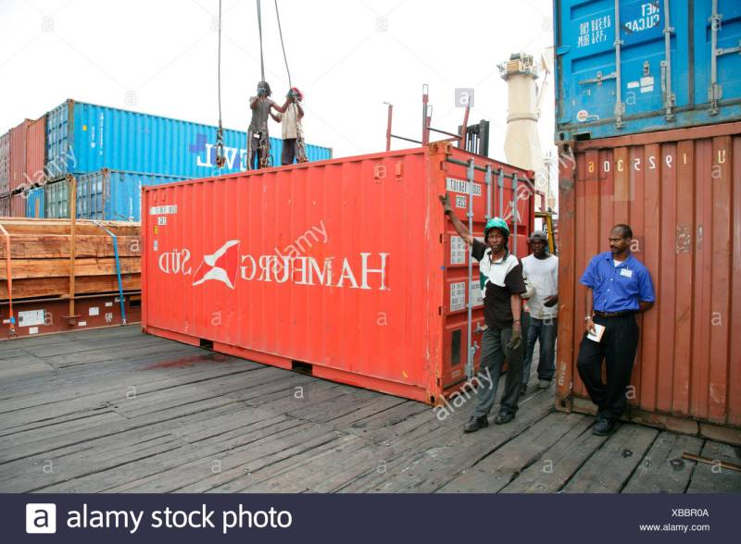

Intro to Linux Containers
- Modern container started in the Linux world and are product of immense contributions for over a period of time from organizations such as Google LLC
- Some of the major technologies in Linux which contributed to massive growth of containers are
  - kernel namespaces
  - control groups
  - union filesystems
  - Docker

Windows Containers
- Microsoft corp has worked along with Docker to bring container technologies to Windows Platform
- Windows Container can be created on
  - Window 10 (Non Home editions)
  - Windows Server 2016 and Later
- Microsoft had changed the core Window Kernel to implement Containers.

Docker Technology
- When we install docker, we have the following components installed into our machine
  - docker client
  - docker daemon (engine)
- Login into docker playground create an instance and execute docker version
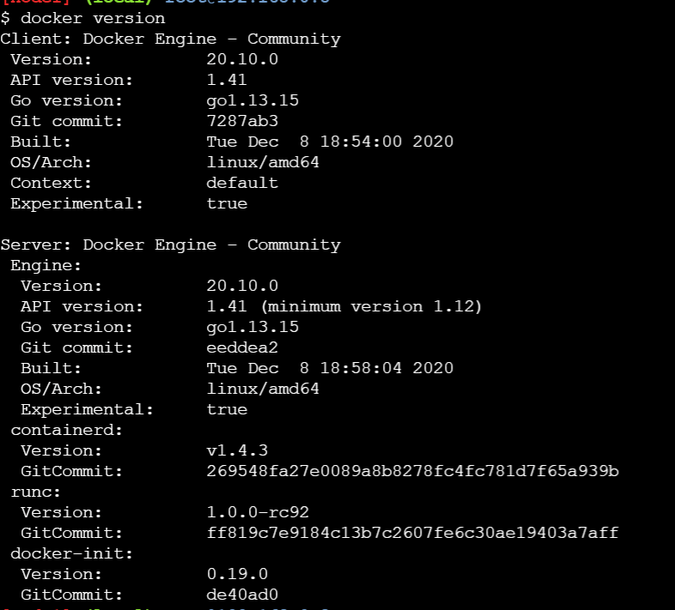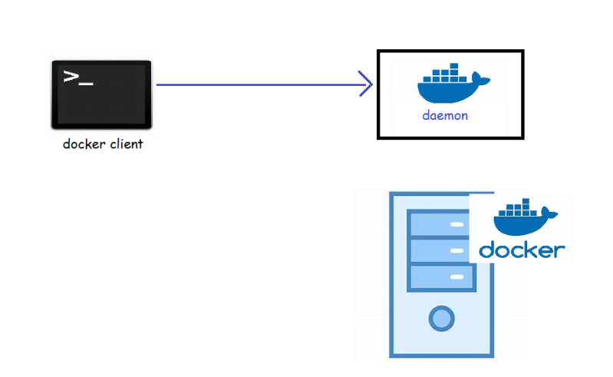
- Let’s try to create one container:
  - from docker client we need to specify we need a container
  - let’s use a simple image called as hello-world
- To run a docker container we need a docker image. Docker has hub which hosts lots of images 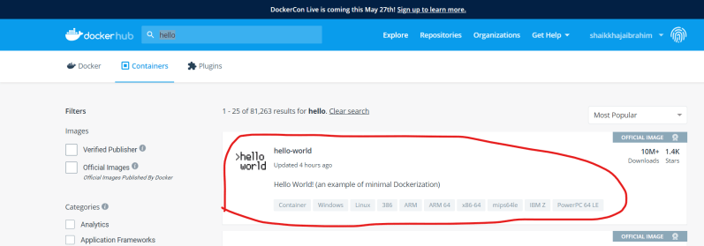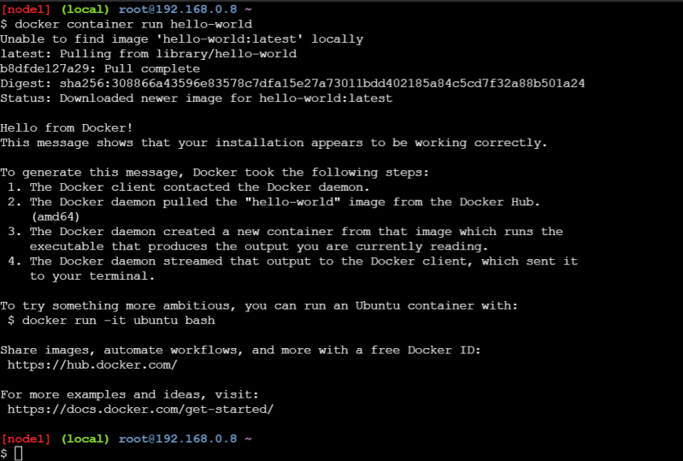
- Now let’s summarize the steps 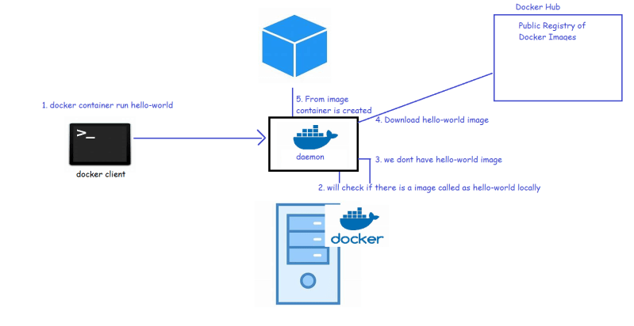
- Now lets try to create one more container with hello-world 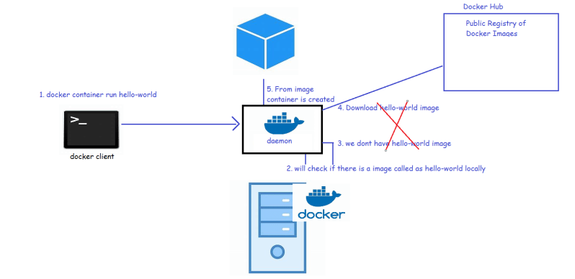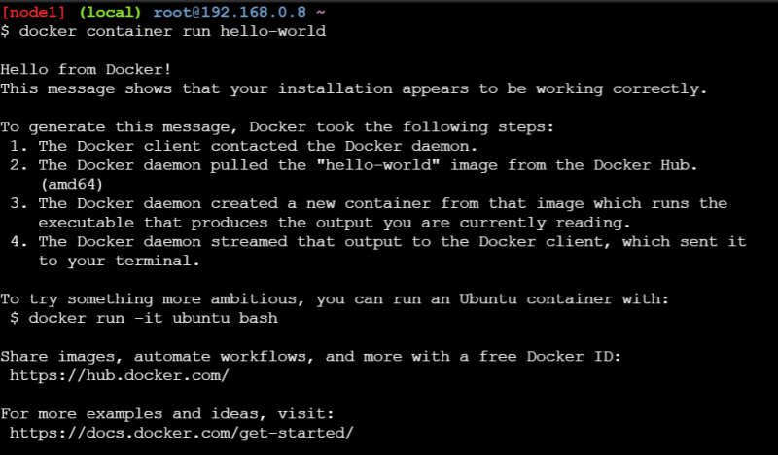
- So, to create container we need images. In reality in container we would want to run our applications developed
- So, we need to create images with our applications in it to create containers
- So, the first task for us is to understand how to create images so that we can run our applications
- Terminology: In case of Docker we will be packaging our applications as Docker images.
Why name Docker? Docker is a British word meaning “a person employed in a port to load and unload ships”

